Truth-Guard Fake News Detection &Verification Tool

Student Name: SATHWIKA REDDY
Mentor Name: V MANJULADEVI
Student Email: bethisathwikareddy@gmail.com
College: Narsimha Reddy Engineering College
Location: Hyderabad

Project Statement
The rapid spread of fake news and online misinformation poses a serious threat to public awareness and decision-making. Manual verification of news content is time-consuming, unreliable, and inaccessible to many users. There is a need for a fast, reliable, and user-friendly system that can automatically analyze news articles, text, and web content to identify misinformation and assess credibility.
Truth Guard – Fake News Detection and Verification Tool addresses this problem by providing a web-based platform that analyzes user-submitted text or URLs using rule-based Natural Language Processing techniques and AI-assisted verification. The system classifies content as Reliable, Suspicious, or Fake, calculates confidence, credibility, and sensationalism scores, and highlights key indicators influencing the decision. To enhance accuracy and explain ability, the tool integrates Google Gemini AI for fact-checking assistance and verification guidance. Truth Guard also maintains secure user authentication, analysis history, and admin-level monitoring to ensure accountability and transparency in misinformation detection.
Key Objectives
Detect fake or misleading news using ML & NLP models
Analyze textual patterns, sentiment, and source credibility
Provide real-time verification results to users
Reduce misinformation spread on social media platforms

Outcomes
• Accurate Fake News Classification
The system successfully classifies news content into Reliable, Suspicious, or Fake categories using a rule-based NLP engine combined with AI-assisted verification.
• Real-Time Content Analysis
Truth Guard delivers ultra-fast analysis responses (under 100 milliseconds) by using optimized text prepossessing, caching mechanisms, and a lightweight detection model.
• Explainable Detection Results
The application generates key findings such as sensational language usage, presence of credible indicators, and emotional intensity, helping users understand why content is flagged.
• AI-Powered Verification Support
Integration of Google Gemini AI provides enhanced fact-checking guidance, credibility assessment, and verification recommendations when advanced analysis is required.
• URL-Based News Verification
The system successfully extracts and analyzes article content directly from news URLs, enabling verification without manual copy-pasting of text.
• Secure User Data Management
User authentication, password hashing, and role-based access ensure secure storage and controlled access to analysis results and chat history.
• Analysis History and Tracking
Each analysis is stored with metadata, allowing users to review past verification, confidence scores, and classification results.
• Admin Monitoring and Control
The admin module enables user management, system monitoring, and analysis oversight, ensuring proper use of the platform.
• System Reliability with Fallback Mechanism
The application continues functioning even when AI services are unavailable by switching to a rule-based fallback mode.
• Scaleless and Maintainable Architecture
Use of modular design, background database saving, and caching ensures the system is efficient, scaleless, and easy to maintain.
Modules to be implemented

1️⃣ User Authentication Module
User model, Flask-Login
User registration & login
Password hashing
Role-based access (user, admin)
Session management

2️⃣ Fake News Detection Module
Rule-based detection using:
Sensational keywords
Credible indicators
Sentiment analysis (NLTK)
Calculates:
Credibility score
Sensationalism score
Confidence score
Classifies news as:
RELIABLE
SUSPICIOUS
FAKE

3️⃣ URL Content Extraction Module
Fetches article text using requests
Parses content using Beautiful Soup
Removes ads, scripts, headers, footers
Uses caching for faster repeat analysis

4️⃣ Gemini AI Verification Module
Integrates Google Gemini API
Provides:
Fact-checking explanation
Misinformation pattern analysis
Verification recommendations
Includes fallback logic when Gemini is unavailable
Stores AI chat history in database

5️⃣ Analysis History & Storage Module
Stores:
Classification result
Confidence score
Key findings
Metadata (word count, indicators)
Background thread saves analysis asynchronously
Supports quick & enhanced analysis modes

6️⃣ Chatbot Module
AI-powered misinformation assistant
Works for:
Logged-in users
Guest users
Stores conversation history for authenticated users

7️⃣ Admin Module
Admin dashboard
User management (add, edit, delete)
Toggle user status
View all analyses
Filter by credibility & confidence

Architecture Diagram
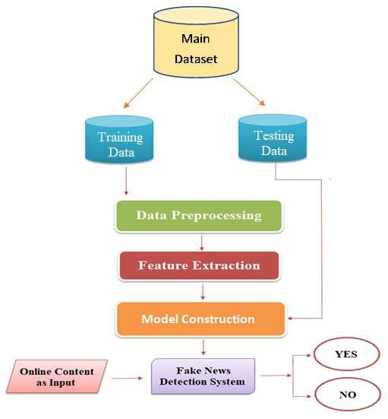

Database Schema

1 User
Stores user and admin details.
Fields: id, email, password, name, role, is active, created at, last login

2 Analysis
Stores fake news analysis results.
Fields: id, title, content, source URL, classification, confidence score,
sentiment score, sensationalism score, credibility score, key findings,
analysis metadata, is quick analysis, user id, created at

3 Chat History
Stores chat bot interactions.
Fields: id, user message, bot response, session id, created at

4 Gemini Chat
Stores Gemini AI chat responses.
Fields: id, user message, Gemini response, model used, response time,
Gemini metadata, user id, created at
Sample code
# Sample code for fake news analysis
from app import Fast News Detector
# Input news content
News text = """
Breaking news! This shocking secret will change your life.
Experts say you must read this immediately.
"""
# Initialize detector
detector = Fast News Detector()
# Perform analysis
result = detector .quick _classify(news _text)
# Display result
print("Classification:", result['classification'])
print("Confidence Score:", result['confidence'])
print("Key Findings:", result['key_ findings'])

Conclusion
Truth Guard – Fake News Detection and Verification Tool successfully demonstrates an effective approach to identifying misinformation using a combination of rule-based NLP techniques and AI-assisted verification. The system provides real-time classification of news content as Reliable, Suspicious, or Fake, along with confidence, credibility, and sensationalism scores to support explainable decision-making. Integration of Google Gemini AI enhances fact-checking capabilities while maintaining system reliability through a fallback mechanism. Secure user authentication, analysis history tracking, and admin monitoring ensure controlled and transparent usage. Overall, Truth Guard offers a fast, reliable, and salable solution for automated fake news detection and verification.

Future Enhancement

In the future, Truth Guard can be enhanced by integrating machine learning and deep learning models to improve fake news detection accuracy beyond rule-based analysis. Support for multi-language content can be added to verify regional and international news. Source credibility scoring and external fact-checking API s can further strengthen verification reliability. Enhancing Gemini AI prompts for deeper analysis, along with visualization dashboards to track detection trends, will improve user understanding. Additionally, extending the system to mobile applications or browser extensions can increase accessibility and real-time misinformation detection.

